PRC Orientation Agenda (2023)
Goal: To provide area and college level review committees information on new standards and some of the motivation behind the new standards; To give new committee members key information on the review process; To begin to establish common understanding and consistent use of information between area and college level committees.
- Role of Reviewers in the RPT Process
- What are the goals of reviewers? Do these goals change at different levels of review? Do these goals change throughout the tenure clock?
- How is the information used? Is the evaluation intended to be formative / summative / both?
- What are some things we can and cannot do as reviewers (e.g. Can I provide feedback directly to the candidate if they ask me? Should I meet with the candidate after a classroom observation?)
- Evaluation of Teaching
- Review of new teaching standards (Ch. 8, 2023 OCOB ARPT)
  - Review and talking through of rubric for Peer Review of Teaching (Appendix, 2023 OCOB ARPT)
  - Note emphasis on observations and course materials.
  - Note emphasis on meticulous evaluation and documentation along the ten factors related to performance as an instructor per the University Faculty Personnel Policies document (7.2.5.2-7.2.5.4, UFPP).
  - Requires the need to request all relevant information from candidates ahead of time.
  - Go over an example of one or two anonymized or hypothetical ‘balanced, comprehensive’ evaluations of teaching effectiveness.
- Use of student evaluations of teaching (SETs)
  - Evidence on what they are good for and what they are not good for.
    - The best evidence suggests that SETs are neither reliable nor valid measures of teaching effectiveness, even when the survey response rate is nearly perfect (Sec 19, RFA.v.Ryerson Stark Expert Report, 2016).
    - They are best viewed as measures of student satisfaction. “While student satisfaction may contribute to teaching effectiveness, it is not itself teaching effectiveness.” (p.10, Boring et. al., 2016)
  - SETs carry large risks of containing biased information
    - Ratings can be biased by several variables such as an instructor’s gender, age, race, and whether the instructor speaks with an accent (among other factors).
    - Ratings can be biased by the nature of the course material, the level of the course and whether the course is required. (Sec 22, RFA.v.Ryerson Stark Expert Report, 2016).
    - Given the many sources of bias in SET and the variability in magnitude of the bias by source, as a practical matter it is impossible to adjust for biases to make SET a valid, useful measure of teaching effectiveness. (p.2, Boring et. al., 2016)
    - Illustrative examples from the best controlled studies:
      - Boring 2017: This article uses data from a French university to analyze gender biases in SETs. The university requires first year undergraduate students to take six mandatory courses, so students do not select their courses when they register. Students' assignment to male and female professors is random. The administration makes students' online ratings of professors mandatory. As all students across all sections of a discipline take the same final exam, it is possible to compare student learning at the end of the semester. The author studies whether a match between student and professor gender has an impact on a professor's overall rating. Gender biases appear to exist: male students give significantly higher ratings to male professors than to female professors. Male students also rate male professors significantly higher than how female students rate both female and male professors. Male students are more likely to give excellent ratings to male professors. The author also finds that students perform equally well on final exams whether their professor was a man or a woman, suggesting no difference in actual teaching effectiveness. Thus, the results suggest that differences in teaching skills are not driving gender differences in evaluations (https://doi.org/10.1016/j.jpubeco.2016.11.006).
      - McNeill 2015: In the experiment this article describes assistant instructors in an online class each operated under two different gender identities. Students rated the male identity significantly higher than the female identity, regardless of the instructor’s actual gender, demonstrating gender bias. The difference between how students rated the two perceived genders stands in stark contrast to the fact that neither the actual male nor actual female instructor received significantly higher ratings than the other. Both instructors performed equally well from the students’ perspective. However, in both cases the same instructor received different ratings depending solely on their perceived gender (https://link.springer.com/article/10.1007/s10755-014-9313-4).
    - The literature on gender and other biases in SETs now spans more than 40 years. You can find more details about this literature here, and a more recent summary of the literature’s main findings can be found in pages 22-26 in https://journals.sagepub.com/doi/epdf/10.1177/15291006231163179, 2023.
  - Moving forward, the best practice regarding the use of SETs is to employ them to provide information about student experiences rather than teaching effectiveness itself (p.1, ASA, 2019). The specific recommendation is to use the SET to evaluate the relationship of the instructor with the students in class, in accordance with the OCOB Task Force recommendations in 2019. Here are the specific steps:
    - Have the candidates summarize and report the fraction of students that strongly agree/agree or strongly disagree/disagree with the statements “The instructor was concerned with student’s learning and was helpful” (item 2.13 in the SET) and “The instructor made me feel comfortable about participating in class” (item 2.14 in the SET).
    - Separate the responses by size and audience (small vs large, lower division, upper division and graduate classes), per Ch. 8, 2023 OCOB ARPT.
    - Since the SETs consist of ordinal, categorical responses, avoid using the arithmetic mean or standard deviation of responses. Instead, follow the example below.

When we aggregate the responses of the formal student evaluations for all students that took a lower division class with this instructor for this academic year we obtain that 82% of the respondents agree that instructor “was concerned with student’s learning and was helpful” and, of those, two thirds strongly agree with the statement. Further, 85% of the respondents agree that instructor made the students “feel comfortable about participating in class” and, of those, four fifths strongly agree with the statement.

    - Do not compare the summarized numbers of an instructor against the number of other instructors (p.2, ASA, 2019). Because of the biases discussed above, among others, these comparisons are not appropriate. Furthermore, neither the OCOB document nor the University document or the union contract require this comparison.
    - MHR and Econ are already doing this.

- Evaluation of Research
- Note changes in new 2023 OCOB ARPT document here
- Evaluation of Service
- Note changes in new 2023 OCOB ARPT document here
- Summary of the Evaluation Process

- Notice that the following language has been struck out of the document:
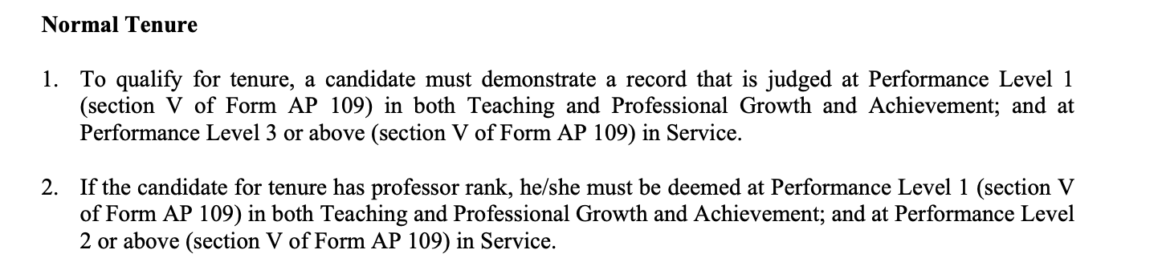
It has been replaced with this:
